Jim Irish | Pastor Benjamin Faircloth | August 8, 2016 - ignitedchurchlife.com

On the Trail
  - ignited church Cook Book
Table of Contents
Cooking Methods………………………………………………………………………………………………………... 2
Dutch Oven …………………………………………………………………………………………………………….3
Cooking Chart…………………………………………………………………………………………………………………… 3
Breads …………………………………………………………………………………………………………………… 4
Easy Unleavened Bread ….…………………………………………………………………………………………….4
Brown Bread
Frying Pan Bread
Hoecakes……..………………………………………………………………………………………………………5
Navajo Fry Bread

Meats………………………………………………………………………………………………………………………6
Jerky
Meat Stew
Mouse Pie………………..……..………………………………………………………………………………..7
Rabbit Stew
Raccoon Fricassee
Veggies …………………………………………………………………………………………………………………..8
Campfire Potatoes
Foil Pockets
Butter Onion Trout ………………….…………………………………………………………………………. 9
Herbed Fish and Carrots
Wilderness Bean Soup
Nature’s Garden ……………………………………………………………………………………………………….. 10
Cattails
Mushrooms
Dandelions

Water Cress ………………………………………………………………………………………………………….…. 11
Wild Leaks ………………………………………………………………………………………………….. 11
Mint
The Master Tonic .… ..……………………………………………………………………………………..…………. 11
To Clarify Fat ……………………………………………………………………………………………………………12
Substitutions ……………………………………………………………………………………………………………. 13
Water Purification ……………………………………………………………………………………………………… 14
Cooking for 100 ………………………………………………………………………………………………………… 15
Non Fat Dry Milk reconstitute
Baking Powder Biscuits ……………………………………………………………………………………………… 16
Hush Puppies
Cookies ……………………………………………………………………………………………………………… 17-18
Small Coffee Cake ……………………………………………………………………………………………………... 19
HOME MADE MREs ………………………………………………………………………………………………… 20

This cook book was compiled for non-profit and articles and recipes are available on the internet. Some recipes are for large groups extracted from the Military Recipe book which is mentioned later. This book to assist those who will be in need and with little knowledge of survival. May you all remain blessed.

Cooking Methods When Using a Dutch Oven

There are four different methods of cooking with a Dutch Oven over a campfire – each achieved by altering the source of heat.

Roasting - In roasting, the heat from your coals should come from the top and bottom evenly. You will place coals on top, as well as pulling the coals up under the pan to create an even heat. Place the same amount of coals on the lid as under the pan. Roasting is best achieved at high temperatures and short cooking times. This will seal in the juices.

Frying and Boiling - When frying and boiling, all the heat should come from underneath the pan. The temperature should be high and kept even during the cooking processes.

Baking - Baking requires cooking mostly from the top. You should place the coals on the lid and underneath the pan at a three to one ratio, with most of the coals on the lid. You will want to watch baking foods very carefully.

Simmering and Stewing - Most of the heat should be from the bottom of the pan. The coals should be placed on the lid and underneath the pan in a four to one ratio, with the bulk of the coals underneath the oven. Regulate the heat in stewing and simmering by moving hot coals underneath the pan
Remember not to rush the cooking process. If you allow adequate time for the oven to heat up before adding the food, and keep the coals manipulated to maintain the temperature, you will have great results.

Number of Coals to Use to Achieve the Desired Temperature

Coals must be used on both the top and the bottom of the Dutch Oven. Use only quality charcoal briquettes for consistent temperature control. The chart below shows you how many coals to use for a desired temperature.

Temperature | 10" Oven |  | 12" Oven |  | 14" Oven
Degrees F | Top | Bottom | Top | Bottom | Top | Bottom
300 | 12 | 5 | 14 | 7 | 15 | 9
325 | 13 | 6 | 15 | 7 | 17 | 9
350 | 14 | 6 | 16 | 8 | 18 | 10
375 | 15 | 6 | 17 | 9 | 19 | 11

Note: Adding one coal to the top and bottom will raise the temperature of the Dutch Oven approximately 25 degrees. Or conversely removing one set of briquettes will lower the temperature by 25 degrees

Easy Unleavened Bread:
Ingredients: 1 cup all-purpose flour, 1/3 cup oil, 1/8 cup salt, 1/3 cup water.
Mix all ingredients using a pastry cutter or two knives until dough is formed, roll into 6 small balls and then make them flat. Place them on cooking surface. Cook for 10 minutes. (You can always add a cinnamon and sugar for a little flavor when finished for breakfast.) If using iron skillet, place pie plate over to make it a mini oven. You can also cut them into strips, add shredded jerky, cheese or whatever you want to spice them up with, bake as above then store for eating on the trail. The more protein you add, the better to get you through.

Brown Bread:
Ingredients: 1 cup flour, 1 cup wheat flour, 1 cup corn meal, 1 cup molasses, 2 cups of water, 1tsp salt, 1tsp baking soda. Utensils: mixing spoon, coffee cans with holes near top edge, piece of wire 12 inches hooked on the end.
Mix: all dry ingredients and then add molasses and water. Place in greased coffee cans about 2/3s full. It should take 2 coffee cans, but you can use 12 oz veggie or fruit can. Place them in a pot filled with about 4 inches of water for steaming. You may want to use small stones in the bottom of the pot to keep the cans from direct contact with bottom of pan. Steam for about one hour and 45 minutes. Remove the cans safely, using a piece of wire to hook on the edge of the cans for easy lifting. Let them cool.

Frying Pan Bread

1 cup flour, 1 tsp. baking powder, 1/4 tsp. salt, Water
Thoroughly mix dry ingredients. Add just enough cold water to make a stiff dough. Working dough as little as possible, form a l-inch thick cake. Lay the cake on a greased, pre-warmed skillet. Brown the bottom of the cake lightly and flip or turn with a spatula to brown the other side. When both sides are lightly browned, prop the skillet in front of the fire and let it bake. Test for doneness by thumping the cake with a spoon handle or stick. A hollow ringing sound indicates doneness. An alternative test is to jab the cake with a twig or matchstick. If the twig comes out clean (no clinging dough), the cake is done.

Hoecakes

1 cup white cornmeal, 1/2 cup flour (optional), 1/2 tsp. salt, Water

Combine the dry ingredients and mix well. The flour is optional, but it will improve the texture of the cake. Add just enough cold water to make a stiff batter. Drop large spoons of batter onto a lightly greased skillet and cook slowly, flip and cook other side.

Navajo Fry Bread

Ingredients: 3 cups flour, shortening, 1/2 teaspoon salt, 1 1/2 teaspoons baking powder
1 1/3 cups warm water

Use either all white or half whole wheat flour. Mix flour, baking powder, and salt. Add warm water and mix. Dough should be soft but not sticky. Knead until smooth. Tear into biscuit size pieces, pat and stretch until it is thin. Poke a hole through the middle, and drop in sizzling hot deep fat, (Lard is the traditional shortening, but you might prefer to use vegetable oil.) Brown on both sides. Drain and serve hot. Eat with honey or jam

Venison or Beef Jerky

Jerky is practically indestructible, lasts almost forever and can be used as either a quick main meal or a basis for soups and stews. The word jerky comes from the method in which the meat is removed from the bones. It was jerked away quickly so as to eliminate many of the sinews. Three pounds of fresh meat equals about 1 lb. jerky.

Method 1: (Indian style) Hang strips of meat on racks made of willows to dry in the sun or sometimes in the smoke of the campfire for a smoked flavor.

Method 2: (pioneer) Rub strips of meat with dry salt and put in a stone crock to "season" for 24 hrs. (use no water) Then remove the strips and hang in sun or smokehouse to dry until very hard.

Method 3: Mix together 3 lbs. salt, 5 Tbsp. black pepper and 4 Tbsp. Allspice.
Skin one thigh of the animal, muscle by muscle removing all the membranes so that only the raw and moist flesh remains. Best size meat are pieces about 1 foot by 6" wide and 2 or 3 inches thick. Rub the salt spice mixture into the meat. Be sure to cover every bit of the meat's surface. Hang each piece by the small end. If the sun is too hot, hang it in the shade. Never let the meat get wet or even damp, take it inside if it rains. Cover the meat with canvas or cloth to protect it from the dew. This will be best at a month old.

Method 4: (Modern Style): Purchase a large beef brisket from your butcher and ask them to slice it very thinly for you. Dip each strip into a bowl of liquid smoke then lay in a large deep dish. Continue to lay each strip until the bottom of the dish is filled. Then sprinkle liberally with garlic salt and lots of pepper. Lay another row of strips on top of the first, in the alternate direction. Continue to dip and season each strip. Marinate for at least 24 hours. Line oven with foil and lay strips directly on the foil very close together and bake at a very low heat for hours or until the strips are very dry. Warning: This will make your house smell of liquid smoke for days.
Meat Stew:
1 ¼ lbs. of meat, 3 carrots, 1 onion, 2 potatoes, 1 tsp salt, 1 tsp pepper, 4 cups water, ½ cup flour. Mix flour, salt and pepper in a plastic bag. Cut up meat in small squares and place in bag with mixture and shake to coat meat. Heat a small amount of oil about a table spoon in your pot and when heated, add meat. When the meat is nice and brown, add the cut up the carrots, onion and potatoes, add water in the pot and cook till tender. Add the remaining flour to thicken the stew. This is just a basic recipe; you can add other items for flavoring or substitute veggies or meat.

Mouse Pie
Ingredients: 5 fat field mice, 1 cup macaroni, 1/2 thinly sliced medium onion
1 medium can tomatoes, 1 cup cracker crumbs, Salt and pepper

Boil macaroni 10 minutes. While it is cooking, fry the field mice long enough to fry out some of the excess fat. Grease a casserole with some of this fat and put a layer of macaroni on it. Add onions, then tomatoes, salt and pepper well. Add field mice and cover with remaining macaroni. Sprinkle the top with cracker crumbs. Bake at 375 degrees about 20 minutes or until mice are well done.

Rabbit Stew
1 rabbit dressed and cut into serving pieces
¼ c flour, Salt and pepper, 4 T Butter, 2 onions chopped, ¼ c chopped carrots
1 c potatoes chopped, Mixed Herbs

Mix flour and seasonings together in plastic bag, Add the rabbit pieces and shake till coated with the mixture. Melt the butter and fry the rabbit pieces until browned. Put the pieces in a large pan and add the onion, carrot and potatoes. Cover with water and empty the bag contents into pot. Cover and cook for three hours.

Raccoon Fricassee

1 Raccoon, 1 onion, sliced into rings, 1/2 C vinegar, 1 1/2 C water, 2-3 tbsp. lard or other fat, 1 bay leaf

Skin the raccoon, remove the musk glands and dress out the carcass. Soak in salt water overnight to draw out the blood. Baking soda can be added to the water to remove any gamey smell. Cut raccoon into serving pieces and dredge in flour seasoned with salt and pepper. Brown in hot fat. Add remaining ingredients. cover and simmer 2 hours or until tender. Thicken the juice with flour and water mixture for gravy. Serve hot with cornbread.

Campfire Potatoes

Ingredients: large baking potatoes, whole onions, red or yellow, dill, parsley, bacon bits
Slice the potato almost all the way through, but leave enough to hold it together. Slice the onion, and put one slice in between each potato slice. Sprinkle with bacon bits and a little dill. Wrap well with heavy aluminum foil and bury in the coals of the fire. Leave untouched for about 45 minutes, and test for doneness by piercing with a fork - the fork should lift out without lifting the potato. Cooking time depends on size of potatoes and strength of fire. Serve with pat of butter and a few sprigs of parsley.
Foil Pockets
Ingredients: Potatoes, Carrots, Tomatoes, Mushrooms, Peppers, Onions, garlic, Salt, Pepper, Olive Oil, Cayenne, 1/4 cup water. (Use whatever veggies you have if what is listed is not available.) Optional: small bits of jerky or bacon.
Tear off a 12" sheet of foil and fold it back over your fist, making a "pocket". Roll the sides in a few turns so the pocket is only open at the top, and roll a turn or two up from the bottom for extra strength. The pocket needs to be leak-proof, and formed well enough to withstand cooking directly in the coals. If your foil is thin, you may need two layers.
Start by lining the bottom of the pocket with thin coat of oil. This helps keep the food contents from burning, and also imparts flavor to the meal. To prepare your meal, start by chopping potatoes and carrots (cut small enough to cook all the way without overcooking everything else), tomatoes, mushrooms, peppers, onions, green beans, etc. and stuff the pockets. For seasoning, use garlic, salt and pepper, olive oil, and a dash of cayenne. Add 1/4 cup of water, fold the top edges of the pocket closed and set directly into the hot coals anywhere from 20 to 40 minutes, depending on how everything's cut. All the veggies slow roast in their own juices!

Breakfast in Bag
One paper lunch bag, Strips of thick bacon, Eggs, Campfire
Directions: Line the bottom of paper bag with bacon, make sure to cover all of the paper and slightly up the sides too, Crack egg(s) and drop on top of the bacon, Fold the top of the bag over a couple of times, Put the bag on the grate over the campfire (no open flames), The eggs are done when the grease from the bacon is about half way up the side of the bag.

Butter Onion Trout
Ingredients: fresh trout, any kind, 1 tablespoon butter, salt and pepper, 1 small onion, sliced
Clean the fish. Leaving the fish whole, stuff the insides with butter, salt and pepper, and as many onions as will fit. Place stuffed trout on buttered foil and wrap up. Place over fire for 7-10 minutes. Open the foil pack, peel the skin off, and enjoy.
Herbed Fish and Carrots
18-inch square of foil, 2 whole small carrots, 1 TBS of margarine or butter
1/2 tsp of dried herb mix, 1/4 tsp lemon pepper or garlic pepper
Fresh fish fillets, about four to five ounces

Lay foil shiny side down on flat surface. Peel carrots and slice 1/4-inch thick. Arrange down the center of the foil. Cut butter into pats and distribute over the carrots. Place fish on top of the carrots and sprinkle the herbs and lemon pepper over the fillet. Cut the remaining butter into pats and distribute over the fish. Fold the foil around the fish and place the packet fish side upon coals. Cook for about 15 minutes, then flip and cook another eight to 10 minutes.

Wilderness Bean soup
This is a good wilderness recipe. Take a cup of dry beans and let them soak overnight. Use a bone from a deer, moose or elk that will fit into your pot, and add this to the beans. Make sure the beans stay covered over completely, then boil until the beans are tender (about an hour) Do not let them boil dry. Then take out the bone and add two medium potatoes diced up, an onion and a cup of carrots diced. Season with salt and pepper. When vegetables are cooked, thicken the soup by adding a little bit of flour.

Cat Tails
This plant has been called the Supermarket of the Swamp because it can be eaten in the spring, summer and winter. They grow everywhere and are easy to find and harvest.
In the spring when the young shoots are growing, you can pick the leaves and eat them like spinach, the white part of the stem is good either cooked or eaten raw, and the "cob" can be cooked and eaten like corn when it's still in the green stage. Once it ripens you can use the pollen like flour.
The root called the rhizome, can be dug up even in the winter and cleaned up and eaten too. The sprouts growing off of the root is also good to eat. The root contains lots of starch, it is best to peel the root, then crush the rhizomes and separate the fiber from the starchy substance. Now let the starch sit in water for a few hours, drain and strain. Use it for flour or dry it and store it for further use. Can also be added to soups and stews.
You can also use the leaves for making baskets and ropes. Very use full plant indeed.
Wild Mushrooms
There are a lot of wild mushrooms that are good to eat. There are also poisonous ones, so you should learn the difference. Morel mushrooms, these are good to eat. The cap on the morel goes right down to the stem and the mushroom itself looks like a really course sponge. If you slice the morel down the middle, it will be hollow. Clean and wash the mushrooms, slice them up and fry in some butter or margarine, salt and pepper to taste.
Dandelion
Here's another wild plant that will help you survive. This is probably one of the most hated weeds there is, it shouldn't be hard to find as it grows everywhere. This is a spring time plant; you want the tender young green leaves before the plant blooms. You can also eat the flower heads, same thing, before they bloom. If you wait till they have finished blooming, you can dig up the root, roast it and grind it up for a coffee like hot drink.
They too are loaded with vitamins A and C, calcium and potassium.
You can eat them hot or cold in a salad. To cook them, first you should wash them in cold water, then put them in a pot and add boiling water over the leaves. Let them boil for a few minutes, drain the water, then add a little butter, salt and pepper to taste. You can cook the buds the same way or you dip them in batter and fry them, or mix them into an omelet. Use your imagination, see what works for you.

Water Cress
Another wild plant that is rich in vitamin C and iron is the water cress plant. It can be found floating on ponds, streams, marshes and river edges. If you cut the leaves of the water cress off at the water line, the plant will keep growing and replenish itself. If you manage it with care you'll never run out of fresh water cress from spring till late fall.
Water cress can actually be grown out of water, just keep it well watered and you can grow it year-round in flower pots. Bring them inside during the winter. If you prefer to grow them in water, get a 5 gal. container and fill it about 3/4 of the ways with water and put your plant in there. You'll have to change water often as the plant doesn't like stagnate water. Water cress can be made into a salad or boil as greens.

Wild Leek

Wild leeks are onion like plants that grow in the wild, and are also called Ramps. They have a strong garlic like aroma, but taste like onions. The young shoots are among the first to come up in the spring and as they age, the leaves will die off and a flower will bloom and then turn to seed. This usually happens in late summer, early fall.
Both the broad leaves and the bulb can be eaten, either fresh or cooked. The leaves should be blanched, then can be frozen, stored or added to meals. You can also dry the leeks for future use.
If you want to replant leeks for a wilderness garden, plant the seeds, not the bulb. If you plant the bulb it may take a few years to reproduce, whereas if you plant the seeds, they'll start producing the following year
Mint
Mint can be found growing in the wilderness or you can plant mint in your garden and have it at your fingertips. If you're not sure if the plant is mint or not, break a leaf open and you should be able to smell that mint aroma immediately. The many things that you can do with mint are;
- The leaves make an excellent tea, especially with honey.
- Used for flavoring sauces and jellies.
- Adding flavor to dishes like pork, vegetables, potatoes & salads.
- Crush mint leaves in a hot bath to freshen and soften the skin.
- Its essential oil, menthol, can be inhaled to soothe a cold.
- Crush the leaves to soothe bites and stings.
- The crushed leaves will also settle an upset stomach, relieve gas and whiten teeth.

The Master Tonic
By Dr. Richard Schulze, University of Natural Healing Based on a tonic by Dr. John Christopher
Raw Unfiltered Unbleached Non-distilled Apple Cider Vinegar, 1 part fresh chopped garlic cloves, 1 part fresh chopped White Onion, 1 part fresh grated Ginger Root,
1 part fresh grated Horseradish Root, 1 part fresh chopped Cayenne Peppers or the hottest peppers available.

Ingredient properties:
-Garlic cloves (anti-bacterial, anti-fungal, anti-viral, anti-parasitical)
-White Onion, or hottest onions available (similar properties to garlic)
-Ginger Root (increases circulation to the extremities)
-Horseradish Root (increases blood flow to the head)
-Cayenne Peppers, or the hottest peppers available, i.e. cayenne, habanero, African Bird, -or Scotch Bonnets, etc. (a great blood stimulant).
Pro-biotic: anti-viral, anti-bacterial, anti-fungal and anti-parasitical.
Fill a glass jar 3/4 of the way full w/equal parts by volume (i.e. a cupful each) of the above fresh chopped and grated herbs. Then fill jar to the top with raw, unfiltered, unbleached, non-distilled apple cider vinegar. Close and shake vigorously and then top off the vinegar if necessary. Store the jars in your cupboard that you would open on a daily basis, for roughly two weeks.
Make sure that when you make this tonic that you shake it every time you open your cupboard door, a minimum of once per day. After two weeks, you are then going to filter the mixture through a clean piece of cotton (old T-shirt, coffee filter, etc.), bottle, cap and label. Remember that all the herbs and vegetables should be fresh (and organically grown if possible), and use dried herbs only in an emergency. If you want, you can save and freeze the solids from this mixture, and add some to your soups and stews.
This tonic is extremely powerful because all the ingredients are fresh. It's power should not be underestimated. This formula is a modern day plague tonic and when added to an incurable routine it can cure the most chronic conditions and stubborn diseases. It stimulates maximum blood circulation, while putting the best detoxifying herbs into the blood. This formula is not just for the sniffles, it has helped to turn around the deadliest infections like some of the new mutated killer viruses that defy conventional antibiotics.
The dosage is 1/2 to 1 ounce, two or more times daily (1- 2 Tbs.). Gargle and swallow. (Don't dilute with water.)
For ordinary infections, 1 dropper full taken 5-6 times a day will deal with most conditions. It can be used during pregnancies, is safe for children (use smaller doses) and as a food it is completely non-toxic. Add some to your salad if you don't want to take it straight. Make up plenty as it does not need refrigeration and lasts indefinitely without any special storage conditions.
To Clarify Fat
For every cup of fat that you render down, add one cup of water and 1/2 tsp. baking soda. Boil and allow the fat to harden. This will also remove any unwanted odors.
Substitutions
If you run out of baking powder, use 1 tsp cream of tartar, 1/2 tsp baking soda equals to 2 tsp baking powder.
3 tbsp. cocoa and 1 tbsp. butter equals 1 square of chocolate
2 tbsp. flour equals 1 tbsp. cornstarch
2 tbsp. liquid, 2 tbsp. flour, 1/2 tbsp. fat & 1 tbsp. baking powder equals 1 egg
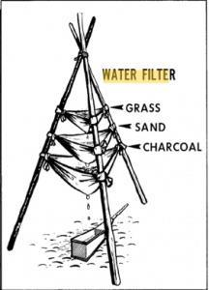

IF YOU ARE PLANNING ON COOKING FOR A LARGE NUMBER OF PEOPLE, HERE ARE SOME RECIPES EXTRACTED FROM THE MILITARY MANUAL WITH A LINK TO DOWNLOAD THE PDF FILE. GOOD TO HAVE FOR A CHURCH TO PREPARE MEALS IN MASS.
http://www.quartermaster.army.mil/jccoe/publications/recipes/index/full_index.pdf

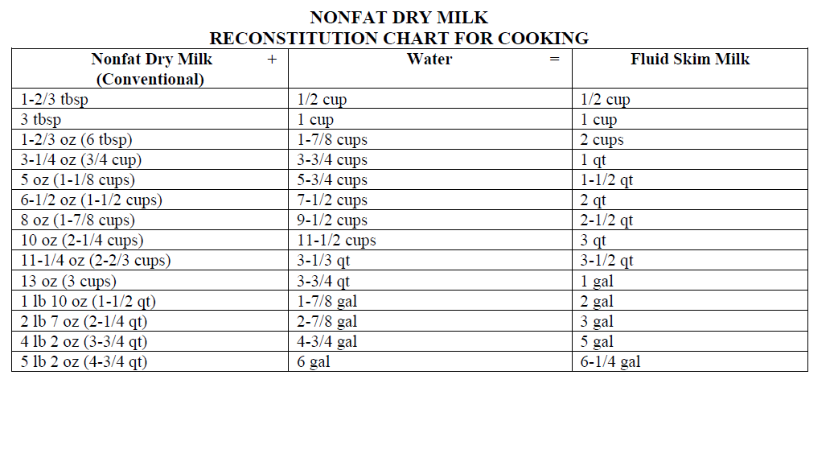
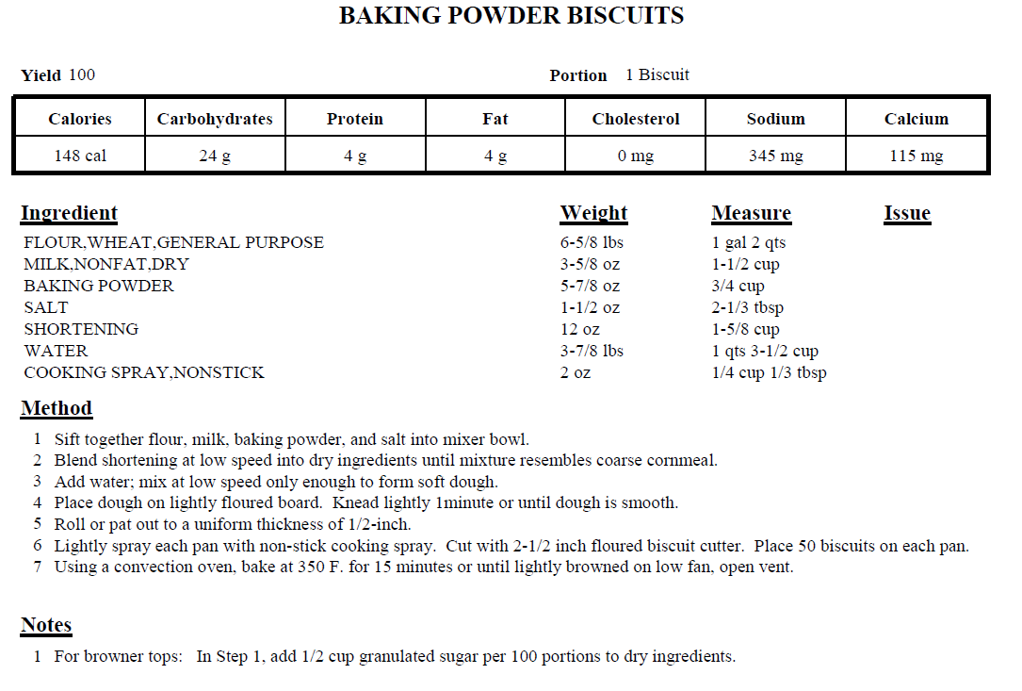
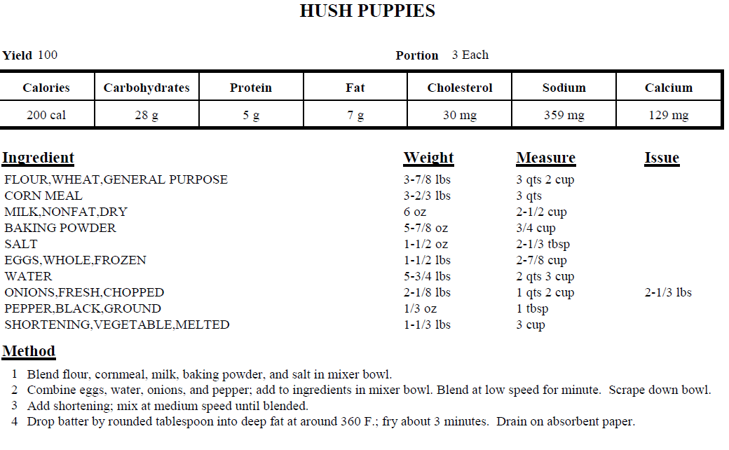
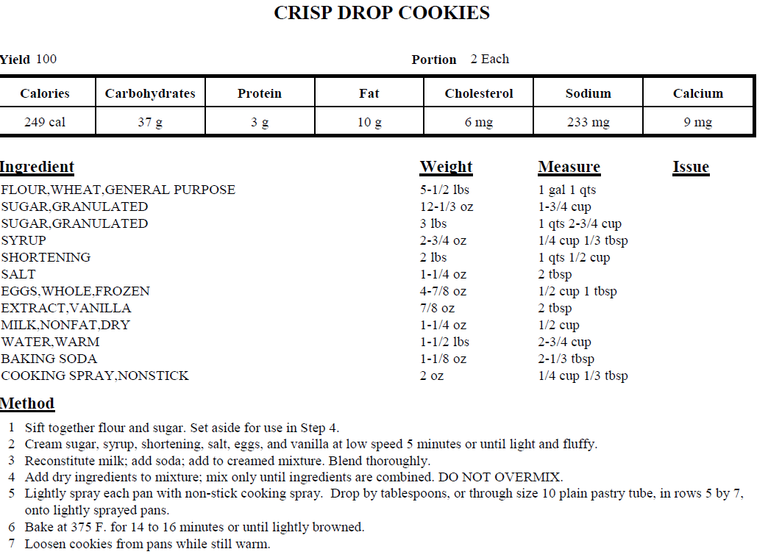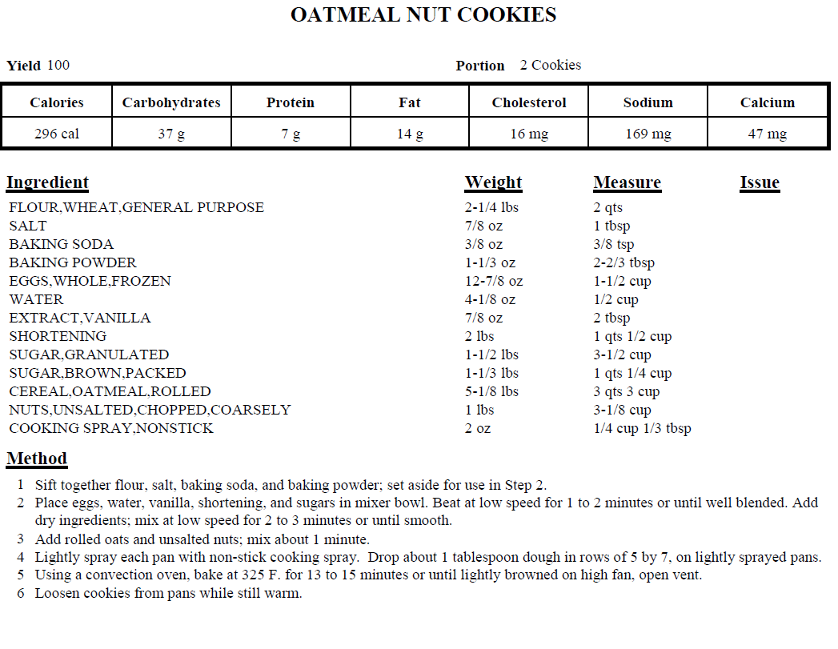

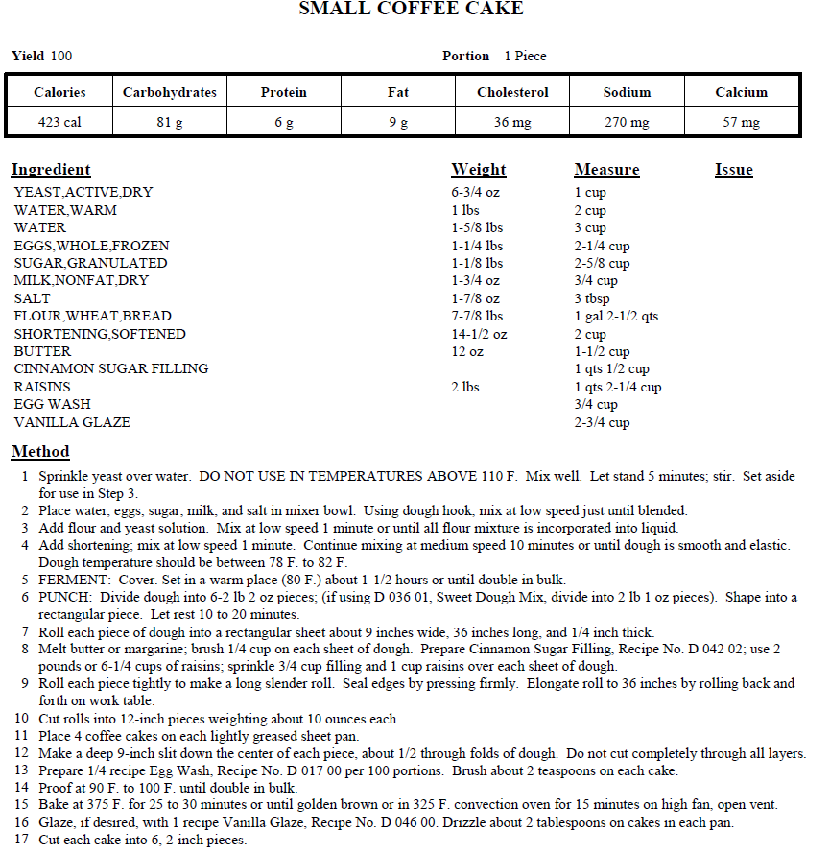

HOME MADE - MEALS READY TO EAT: (MRE)
INDIVIDUAL SIZE
1 GALLON PLASTICE ZIP LOCK BAG + 4 SNACK SIZE PLASTIC BAG
1ST SNACK SIZE ZIP BAG:
2 - PACK INDIVIDUAL WRAP CRACKER, 1 - JELLY PACKET, 1 POWDERED DRINK MIX FOR 12OZ OF WATER.
2ND SNACK SIZE BAG:
1 - PACK MATCHES, 6 FOLDED TISSUES, TOOTH PICK, 1 PIECE OF HARD COATED MINT GUM, 1 PKT INSTANT COFFEE, 1 PKT CREAMER, 1 SUGAR
1 – GRANOLA BAR OR WHATEVER VARIETY OF SNACK BAR
1 – PACK INDIVIDUAL TUNA IN FOIL POUCH OR OTHER FOIL POUCHED MEAT
1 – SMALL PACK OF DRIED OR DEHYDRATED FRUIT
1 – PACKET COCOA MIX
3RD SNACK BAG:
1 PLASTIC FORK, SPOON AND KNIFE, 1 WET WIPE IN 4TH SNACK BAG.
PLACE ALL IN LARGE 1 GALLON PLASTIC BAG AND SEAL, REMOVING AS MUCH AIR AS POSSIBLE. IF YOU FIND THAT THIS BAG IS TOO BIG, TRY MOVING DOWN TO A 1 QT BAG OR FIND A HAPPY MEDIUM. VACUUM SEAL WILL REDUCE THE SIZE AND KEEP FROM SPOILAGE.
FAMILY SIZE MRE
USE SAME STORAGE BAGS AS ABOVE.
USE 1^{ST,} 2^{ND,} AND 3RD SNACKS BAG PER INDIVIUAL MEMBER.
IF YOU WANT TO PREPARE MEALS TO STORE, ENSURE THEY ARE VACUUMED SEALED WITH A NATURAL PRESERVITIVE.
RECOMMEND: MEAT LOAF, CORNED BEEF, MAC AND CHEESE, CHILI, ANY CASSAROLE AND YOU MUST INCLUDE VEGGIES THAT WILL KEEP, MOSTLY A BEAN OR PEA. (REMEMBER, ALL COOKING IS WITHOUT A MICROWAVE). BEST IF THESE CAN BE EATEN WITHOUT COOKING IF NECESSARY.
THINGS TO CONSCIDER:
BREAD – IF YOU CAN GET THE SMALL PARTY SIZE BREADS, THOSE WOULD BE PERFECT TO SUBSTITUE FOR CRACKERS, YOU HAVE A VARIETY CHOICE.
PEANUT BUTTER - IF YOU CAN FIND THESE IN PACKETS, GREAT, IF NOT, CLEAN OUT A TOOTH PASTE TUBE AND FILL FROM BACK END FOR SQUEEZABLE USE. LABEL THE TUBE AND TAPE THE BOTTOM.
YOU CAN ALSO USE SQUEEZABLE CHEESE AND ALWAYS REFILL.
MEATS: BEST MEATS TO USE – JERKY, SEASONED MEAT STICKS, DRIED BEEF.
AVOID CANS IN MAKING MREs.
AVOID CHOCOLATE BARS, IT IS OKAY IF CHOCOLATE CHIPS ARE IN THE GRANOLA BAR.
OTHER ITEMS YOU CAN SUBSTITUTE DEPENDING ON YOUR TASTE, ADD A TEA BAG INSTEAD OF COFFEE, OMIT CREAMER FOR 2ND SUGAR, ETC
USE THE MATCHES AT THE END OF THE MEAL TO DESTROY WASTE, DO NOT BURRY, BE CONSIDERATE TO THE ENVIRONMENT AND DON’T LEAVE A TRAIL. ALSO CONSIDER WHAT TO DO WITH ANY LEFT OVER ITEMS.
IF YOU WISH TO HEAT YOUR MEAL, CUT OUT A 12 INCH PIECE OF FOIL AND PLACE IN BAG, SEE HOW TO MAKE FOIL POUCH ON PAGE 8.
MREs SHOULD BE USED ONLY WHEN YOU CANNOT COOK WITH OPEN FIRE AND SHOULD BE CONSIDERED FOR USE ON THE TRAIL FOR BRIEF STOPS OF REST.
CANTEENS: EACH PERSON HAS TO CARRY A 1 QT CANTEEN AT A MINIMUM, NO EXCEPTIONS.

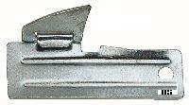
THIS IS A P38 CAN OPENER AND CAN BE ORDERED ON LINE OR FOUND IN AN ARMY SURPLUS STORE ABOUT 50c A PIECE. THESE ARE VERY HANDY FOR CANS IF YOU DECIDE TO HAVE CANS AVAILABLE AT YOUR CAMP SITE AND CAN BE HUNG FROM A KEY CHAIN OR AROUND YOU NECK TO KEEP SECURE.

IN MANY STORES YOU CAN FIND SAMPLE SIZE PRODUCTS THAT WILL BE GREAT AND TAKE UP LESS ROOM IN YOUR BACK PACK. SUCH AS TOOTH PASTE, SHAMPOO, SOAP, DENTAL FLOSS, DEORDERANT THAT YOU CAN KEEP TOGETHER IN A SNAP SEALED BAG.
TOILET PAPER: YOU MAY HAVE WONDERED WHY 6 TISSUES IN AN MRE KIT. THESE RE TO BE USED AS TOILET PAPER AND THE WET WIPE FOR AFTER MEAL CLEAN UP. BUT THESE ARE YOUR CHOICES, MY SUGGESTIONS.
YOU HAVE TO LEARN TO BE CONSERVATIVE IN THE USE OF ALL YOUR ITEMS TAKING INTO CONSIDERATE TIME FACTORS.
WHILE ON THE TRAIL: IF YOU ARE IN A GROUP:
1ST BACK PACK SHOULD CONTAIN MEDICAL SUPPLIES – THE PERSON TO CARRY THIS SHOULD BE GOOD AT FIRST AID. 1 EACH ITEM PER PERSON IN GROUP: ACE BANDAGES, ALCOHOL WIPES, ANITBIOTIC OINTMENT, ASPRIN, ANTIHISTIMINE, EPPY PIN, SCISSORS, 2” CLOTH TAPE, 2 PIECES OF ½”X4”X12” WOOD FOR SPLINTS, SMALL SEWING KIT, SNAKE BITE KIT. THESE ARE A MINIMUM. ADD WHAT YOU THINK YOU MAY WANT.
2ND BACK PACK SHOULD CONTAIN LARGE GROUP MESS KIT: BAMBOO CUTTING BOARD 10”X12”, 1 PACK CUTTING KNIVES, 3 WOODEN SPOONS, SMALL SPICE PACKETS, 1 PACK DRIED BEANS, 1 PACK DRIED ONIONS, 1 PACK RICE. STERNO, CAST IRON PAN OR POT. SIZES ARE YOUR CHOICE WHAT THIS PERSON CAN CARRY.
3RD BACK PACK: ROPES, TAPE, BATTERIES, SHARPENING STONE, HATCHET, WIRE, 24” CLOTH STRIPS, ENTRENCHING TOOL OR SMALL SHOVEL, 12-14” BUNGY CORDS, STERNO OR HAND SANTIZER FOR FUEL.
4TH BACK PACK: MAPS, COMPASS, PROTRACTOR, PENCILS, POCKET SIZE NOTEBOOKS, FLASHLIGHT WITH COLORED LENS, 12” RULER, BAMBOO CUTTING BOARD 10”X12” FOR USE WITH MAPS.
EACH BACK PACK MUST ALSO CONTAIN INDIVIDUAL MRE, PERSONAL HYGENE ITEMS. BACK PACK ROTATION IS OPTIONAL BUT MAKES GOOD PRACTICE FOR TEAM WORK. EACH PACK SHOULD HAVE AN INVENTORY LIST MAINTAINED.
KEEP ALL ITMES DRY OR SEALED UP IN 1 GALLON PLASTIC BAGS. FIRST AID ITMES SHOULD BE PACKED FOR EASY ACCESS.

